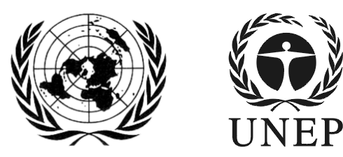 | SAICM/ICCM.4/INF/36
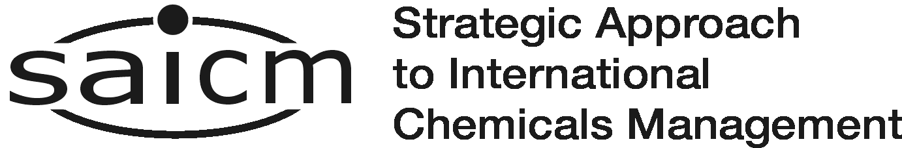 |  | Distr.: General  28 September 2015  English only
International Conference on Chemicals Management
Fourth session
Geneva, 28 September–2 October 2015
Item 4 (a) of the provisional agenda∗
Progress and challenges towards the achievement of the 2020 goal of sound chemicals management:
regional and sectoral achievements, strengths and challenges in the context of working towards the objectives of the Strategic Approach Overarching Policy Strategy
Report on the Asia-Pacific Economic Cooperation Chemical Dialogue
Note by the secretariat
The secretariat has the honour to circulate, for the information of participants, a report on the 15th Asia-Pacific Economic Cooperation Chemical Dialogue, held in Cebu, Philippines, on 27 August 2015, submitted by Asia-Pacific Economic Cooperation (see annex). The report is presented as received by the secretariat, without formal editing.
Annex

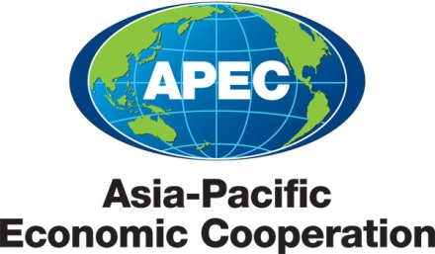

2015/SOM3/CD/018/Rev. 1
Agenda Item: 5B

CD Contribution to ICCM-4

Purpose: Consideration

Submitted by: APCIC

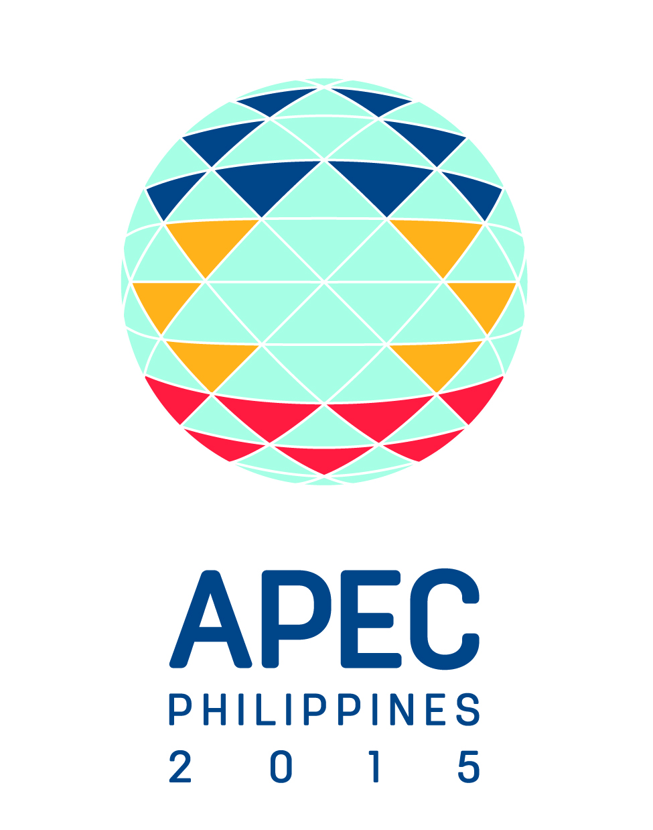 | 15th Chemical Dialogue  Cebu, Philippines  27 August 2015

The APEC Chemical Dialogue: A Regional Contribution to SAICM Implementation

Background
The Asia-Pacific Economic Cooperation (APEC) is a regional forum that promotes regional economic integration among its 21 member economies. APEC’s members account for approximately 40% of the world’s population, around 54% of global GDP, and about 44% of world trade. APEC operates on the basis of non-binding commitments, open dialogue, and equal respect for the views of all participants. Decisions made within APEC are reached by consensus and commitments are undertaken on a voluntary basis. APEC meets throughout any one year at the senior officials’ level, and annually at Ministerial and Leaders level. Further information on APEC can be found at www.apec.org.
APEC has established a number of groups to promote its objective of facilitating economic growth, cooperation, trade and investment in the Asia-Pacific region in different sectors. Under its Committee on Trade and Industry, APEC established a Chemical Dialogue in 2002. The Dialogue serves as a forum for government officials and industry representatives to find solutions to challenges facing the chemical industry and users of chemicals in the Asia-Pacific region. It reflects recognition among APEC member economies of the importance of engaging with the private sector and building public-private sector dialogue and cooperation for mutual benefit.
Issues addressed by the Chemical Dialogue include trade liberalization and facilitation in the chemical sector, capacity building, and improving regulatory policies and business practices to promote regional integration while ensuring health, safety and environmental protection. The work of the Chemical Dialogue reflects broader APEC strategic objectives, such as strengthening regional economic integration and expanding trade; promoting green growth; expanding regulatory cooperation and advancing regulatory convergence.

Strategic Framework for Chemicals in the Asia-Pacific Region
In 2009, the Chemical Dialogue made a submission to ICCM-2 outlining its work on Principles for Best Practices for Chemical Regulation and on efforts to promote clarity and consistency in the implementation of the Globally Harmonized System for Classification and Labeling of Chemicals (GHS). In 2012, the Chemical Dialogue provided an update to ICCM-3 on progress in addressing SAICM’s five core objectives as a regional contribution to SAICM implementation. The ICCM-3 submission highlighted the Chemical Dialogue’s adoption of a Strategic Framework for Chemicals in the Asia-Pacific Region. The Strategic Framework sets out five overarching objectives for the Chemical Dialogue’s work:
- To facilitate alignment with APEC Leaders’ goals for sustainable economic growth and regulation.
- To promote regulatory capacity and convergence in order to facilitate trade while enhancing environmental and health protection.
- To enhance chemical management and product stewardship over the life cycle and in cooperation with other initiatives and institutions where appropriate, e.g. the OECD, UN, SAICM, WHO.
- To identify barriers to using chemicals, products and processes to achieve sustainable and innovative solutions to global problems.
- To strengthen the positioning of the sector globally as an enabler of technological change and innovation.

To achieve these objectives, the Strategic Framework identifies three shared goals around which the work of the Chemical Dialogue will be organized:
- Shared Goal 1: Expand and support cooperation and mutual recognition among chemical regulators in the Asia-Pacific Region.
- Shared Goal 2: Enhance understanding of the chemical industry’s role as an innovative solutions industry.
- Shared Goal 3: Encourage chemical product stewardship, safe use, and sustainability.

The Strategic Framework is a living document, with an action plan that is continually updated as projects are completed and new initiatives begun. The action plan is structured around the three shared goals listed above. For the purposes of highlighting the work of the Chemical Dialogue as a regional contribution to SAICM implementation since 2012, projects and initiatives listed under the action plan are listed below according to how they relate to the five SAICM core objectives.

Risk Reduction
The Chemical Dialogue has committed to the following actions and initiatives to promote risk reduction in the Asia-Pacific region:
- Held a workshop to promote chemical regulatory cooperation and further implementation of the APEC Best Practice Principles for Chemical Regulation (August 2014).
- Held a joint seminar with the APEC Economic Committee on the implementation of Good Regulatory Practices for Chemical Regulation, as a follow-up to the 2014 workshop (August 2015).
- Conducted (through the Chemical Dialogue Regulators Forum) a risk assessment workshop in Bangkok as a best practice/train the trainers exercise (November 2012).
- Established a cross-fora working group with the APEC Oceans and Fisheries Working Group to promote innovative solutions to problems posed by marine debris (July 2014).
- Promoted the expansion and broader usage of the GHS Reference Exchange and Tool (GREAT) web portal that serves as a clearing house to collect and provide information on GHS implementation, including translation into local languages: http://great.cla.gov.tw/ENG/index.aspx (ongoing).
- Strengthened efforts, beginning in January 2015, to promote broader and more aligned implementation of GHS, and approved an action plan to move these efforts forward (ongoing).
- Concluded a Principles Framework for GHS and Consumer Goods for use by member economies (July 2013).
- Promoted global and regional chemicals management initiatives, including voluntary industry programs such as Responsible Care and the Global Product Strategy, to strengthen domestic capabilities for chemicals management (ongoing).
- Maintained and expanded a website to assist emergency responders in member economies in responding to transportation emergencies involving the movement of dangerous goods, particularly across borders: http://global.chemtrec.com.

Knowledge and Information
Actions and initiatives to promote the sharing of knowledge and information on chemical management issues include:
- Provided reports to APEC Trade Ministers on GHS implementation status from 2013-2015.
- Approved a Virtual Working Group on GHS Data Exchange in July 2013, and promoted interaction with the UN Subcommittee of Experts on GHS (UNSCEGHS) to share information on ongoing work (ongoing).
- Prepared a comparison of GHS implementation across APEC economies, and began consideration of ways that APEC can help reduce divergences (August 2015).
- Received case study presentations from APEC economies on their implementation of chemical regulatory cooperation initiatives at the national and sub-regional level (ongoing).
- Developed a glossary of regulatory terminology as a reference tool and living document (August 2014).

Governance
Projects and initiatives under the Strategic Framework related to improving governance include:
- Maintained an APEC Chemical Regulators Forum via annual meetings to discuss regulatory best practice (ongoing).
- Agreed to a Regulators Forum Action Plan to guide future work (August 2014)
- Established, in July 2013, a Virtual Working Group on Regulatory Cooperation and Coherence to consider opportunities for improving the business environment “behind the border” and promote enhanced regulatory cooperation on chemicals issues in the APEC region, as a contribution to broader APEC work on regulatory cooperation (ongoing).
- Explored opportunities for expanded collaboration with the OECD Clearing House on New Chemicals and held joint meetings in 2013 and 2014.

Capacity Building and Technical Assistance
Projects and initiatives related to strengthen capacity and providing technical assistance in the Asia-Pacific region include:
- Began consideration of proposals from APEC economies for multi-year capacity building for chemical regulators on regulatory cooperation (January 2015).
- Developed a smart tool reporting template to streamline GHS reporting (August 2015).
- Held an industry-funded workshop on intermediate to advanced capacity building for risk assessment of metals and metal compounds (August 2015).
- Held an awareness-raising on the importance of comprehensive land-based waste management for reducing marine debris, and the available innovative solutions (August 2015).
- Developed a self-funded proposal for developing a coordinated approach to waste management at two beta sites within the APEC region to demonstrate the feasibility of reducing waste emissions into the ocean (ongoing).
- Shared information and promoted continued implementation of the Joint Article Management Program (“JAMP”) and the Supply Chain Risk management and Useful Mechanism (“SCRUM”) for sharing chemical risk management information through the supply chain (ongoing).

Illegal International Traffic
The Chemical Dialogue encourages broader activities within APEC to promote rules based international trade and prevention of illegal shipments in chemicals.

Conclusion
Since its submission to ICCM-3 in 2012, the APEC Chemical Dialogue has made considerable progress in developing projects and initiatives that both promote the objectives of the Dialogue and serve as a regional contribution to SAICM implementation. One of the key lessons from these projects and initiatives is the importance of SAICM implementation at the national level in promoting sound chemicals management. Regional forums such as APEC can help to provide support and coordination for these national efforts, including through efforts to promote regulatory cooperation. Looking ahead, the Chemical Dialogue will continue to develop new and existing initiatives under the Strategic Framework to address current and emerging challenges in the region, and respond to the priorities set by APEC Leaders.

__________________________

∗ SAICM/ICCM.4/1.
APEC’s 21 member economies are Australia; Brunei Darussalam; Canada; Chile; People’s Republic of China; Hong Kong, China; Indonesia; Japan; Republic of Korea; Malaysia; Mexico; New Zealand; Papua New Guinea; Peru; The Republic of the Philippines; The Russian Federation; Singapore; Chinese Taipei; Thailand; United States of America; Viet Nam.
SAICM/ICCM.2/INF/42
SAICM/ICCM/3/INF/32

